**Name: MUHAMMAD HUZAIFA**

**Roll No: BIT-24S-017**

**Lab 5:**

**Task 1:**

Basic Task: Write a program that checks if a given number is positive, negative, or zero.

**Program:**

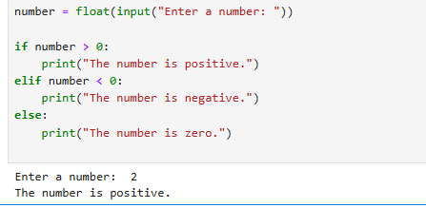

**Task 2:**

Intermediate Task: Write a program that takes user input and determines whether it's a even or odd.

**Program:**

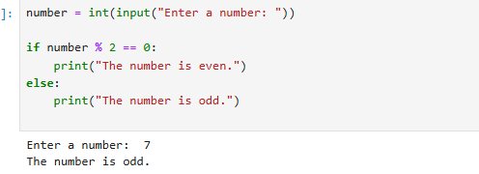

**Task 3:**

Advanced Task: Create a program that asks user to print:

"Excellent" if marks are above 80

"Good" if marks are between 60 and 80

"Needs Improvement" if marks are below 60

**Program:**

